Spearman rank correlation: EURUSD and AUDUSD
Method 02 / daily log returns / Alpari D1 full available history

Study setup
Logical pair: EURUSD , AUDUSD
Broker symbols: EURUSD_i , AUDUSD_i
Snapshot: 2026-11-03_majors_alpari_D1
Timeframe: D1
Matched return window: 1999-01-05 to 2026-11-02 (UTC bar dates)
Matched return count n: 7201
Dropped unfinished last bar dated 2026-11-03 UTC after a tick-volume check against the prior complete day.
Complete matched rows (CSV): EURUSD-AUDUSD_Spearman_D1.csv
Complete matched rows (HTML table): EURUSD-AUDUSD_Spearman_D1_data.html

Method carried forward
Spearman rho is Pearson correlation on the ranks of matched daily log returns of close, ln(close_t / close_t-1), in the broker quote direction. Ties use average ranks. Quotes are not inverted. rho is symmetric under swap of the two symbols. rho = 0 means no consistent rank-order link in this sample; it does not mean no link of any kind. The score is not a cause, not a lead, and not a trading signal. Daily rows are not independent draws, so the two-sided p-value and approximate Fisher interval are reported and treated as secondary to rho. Same-sample Pearson r is shown only as a side check; a large rho minus r gap can flag outliers or a non-straight link.

Results
Spearman rho: 0.546799
Two-sided p-value: 0
Approximate 95% Fisher interval: [0.530400, 0.562789]
Same-sample Pearson r: 0.556324
rho minus r: -0.009525

Conclusion
Over 7201 matched daily log-return rows for EURUSD and AUDUSD (broker quote directions unchanged), Spearman rho is 0.5468 (positive, moderate rank-order association in this sample). Approximate 95% Fisher interval: [0.5304, 0.5628]. Same-sample Pearson r is 0.5563 (rho minus r = -0.0095). Two-sided p under the usual independent-ranks model is 0; that model does not match linked daily FX returns, so treat p as secondary. This does not establish cause, lead-lag, or a lasting trading rule.

Charts
Daily closes

Daily log returns
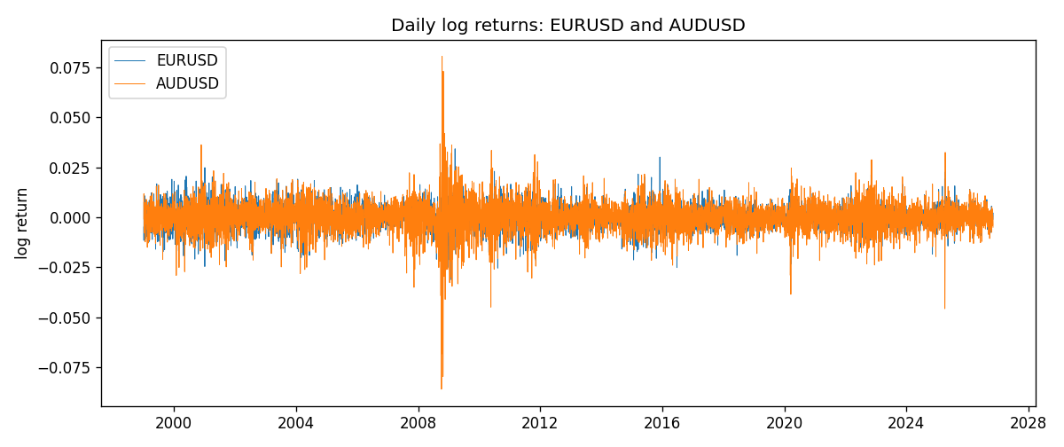
Log-return scatter
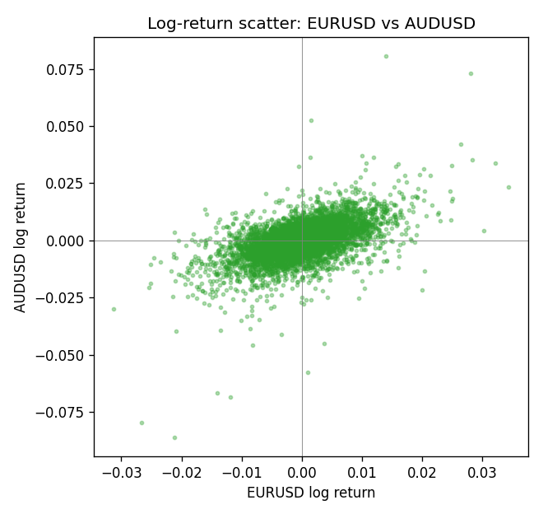
Rank-rank scatter
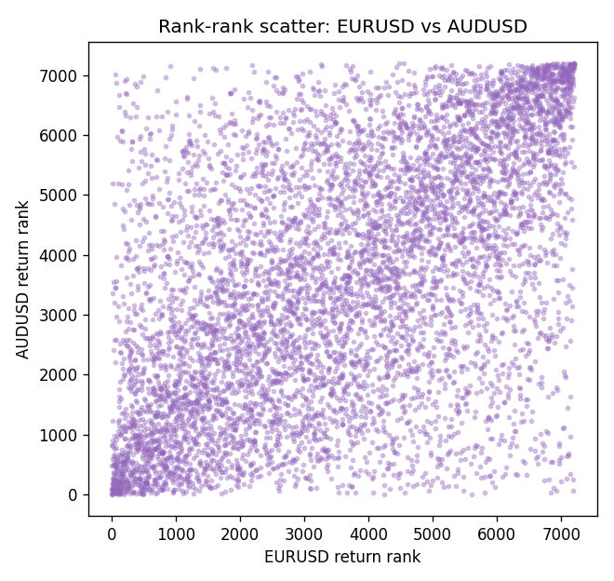

Data report
Every matched row that entered Spearman rho is stored in the sibling CSV named EURUSD-AUDUSD_Spearman_D1.csv. That file is the complete data archive for redrawing charts. Embedding all rows as a Word table is impractical at this length; the Word file holds the column list, column summaries, and the first and last 15 matched rows.
Columns: time, EURUSD_open, AUDUSD_open, EURUSD_high, AUDUSD_high, EURUSD_low, AUDUSD_low, EURUSD_close, AUDUSD_close, EURUSD_tick_volume, AUDUSD_tick_volume, EURUSD_spread, AUDUSD_spread, EURUSD_real_volume, AUDUSD_real_volume, EURUSD_log_return, AUDUSD_log_return
Column summaries (matched calculation rows)
column | count | mean | std | min | 25% | 50% | 75% | max
EURUSD_open | 7201 | 1.1813268 | 0.15086382 | 0.8272 | 1.08608 | 1.16615 | 1.29393 | 1.5995
AUDUSD_open | 7201 | 0.75197127 | 0.13525779 | 0.4785 | 0.66105 | 0.73142 | 0.80912 | 1.10284
EURUSD_high | 7201 | 1.1864593 | 0.1514619 | 0.8326 | 1.0902 | 1.17128 | 1.29926 | 1.6038
AUDUSD_high | 7201 | 0.75602178 | 0.13581838 | 0.4878 | 0.6647 | 0.7349 | 0.81518 | 1.10795
EURUSD_low | 7201 | 1.1763142 | 0.15018707 | 0.8227 | 1.08202 | 1.16257 | 1.28834 | 1.5865
AUDUSD_low | 7201 | 0.74791431 | 0.13457219 | 0.4775 | 0.6577 | 0.72758 | 0.8042 | 1.0975
EURUSD_close | 7201 | 1.1813656 | 0.15083992 | 0.8267 | 1.08601 | 1.16617 | 1.29395 | 1.5997
AUDUSD_close | 7201 | 0.75202148 | 0.13524071 | 0.4786 | 0.6612 | 0.73175 | 0.80916 | 1.10169
EURUSD_tick_volume | 7201 | 103004.8 | 173409.64 | 469 | 9389 | 52708 | 99441 | 1471626
AUDUSD_tick_volume | 7201 | 77347.024 | 138135.9 | 109 | 5434 | 43320 | 71320 | 1234623
EURUSD_spread | 7201 | 19.396195 | 16.574381 | 0 | 8 | 12 | 30 | 50
AUDUSD_spread | 7201 | 30.819886 | 16.887485 | 0 | 13 | 30 | 50 | 50
EURUSD_real_volume | 7201 | 4.0238636e+10 | 1.6675367e+11 | 0 | 0 | 0 | 0 | 3.6149665e+12
AUDUSD_real_volume | 7201 | 5.2420906e+09 | 1.2538049e+11 | 0 | 0 | 0 | 0 | 3.811512e+12
EURUSD_log_return | 7201 | -7.54e-06 | 0.00580172 | -0.03123819 | -0.00324684 | 0 | 0.00325501 | 0.03433183
AUDUSD_log_return | 7201 | 2.459e-05 | 0.00754509 | -0.08602525 | -0.00385511 | 0.00028229 | 0.00415126 | 0.0806166
First 15 matched rows (selected columns)
time | EURUSD_close | AUDUSD_close | EURUSD_log_return | AUDUSD_log_return | EURUSD_tick_volume | AUDUSD_tick_volume
1999-01-05 | 1.1758 | 0.6215 | -0.0048360507 | -0.00080418179 | 4793 | 1103
1999-01-06 | 1.1623 | 0.6289 | -0.011547966 | 0.011836351 | 4828 | 1412
1999-01-07 | 1.1712 | 0.6345 | 0.0076280636 | 0.0088650256 | 5076 | 1468
1999-01-08 | 1.1585 | 0.6347 | -0.010902799 | 0.00031515916 | 5120 | 1225
1999-01-11 | 1.1503 | 0.6393 | -0.007103287 | 0.0072213815 | 4960 | 1318
1999-01-12 | 1.1555 | 0.6362 | 0.0045103728 | -0.0048608485 | 5248 | 1908
1999-01-13 | 1.1681 | 0.6312 | 0.010845346 | -0.0078902098 | 6623 | 1829
1999-01-14 | 1.1681 | 0.6295 | 0 | -0.002696916 | 5472 | 1593
1999-01-15 | 1.1563 | 0.634 | -0.010153245 | 0.007123101 | 6529 | 1604
1999-01-18 | 1.1605 | 0.6346 | 0.0036256946 | 0.00094592471 | 4054 | 1430
1999-01-19 | 1.1603 | 0.6392 | -0.00017235436 | 0.0072225153 | 5595 | 1733
1999-01-20 | 1.1566 | 0.64 | -0.0031939256 | 0.0012507819 | 5736 | 1901
1999-01-21 | 1.1601 | 0.6405 | 0.0030215416 | 0.00078094498 | 5230 | 1946
1999-01-22 | 1.1587 | 0.6327 | -0.0012075213 | -0.012252745 | 4559 | 1875
1999-01-25 | 1.1552 | 0.6302 | -0.0030251979 | -0.0039591468 | 3774 | 1413
Last 15 matched rows (selected columns)
time | EURUSD_close | AUDUSD_close | EURUSD_log_return | AUDUSD_log_return | EURUSD_tick_volume | AUDUSD_tick_volume
2026-10-13 | 1.11965 | 0.69821 | 0.0037402957 | 0.0035007712 | 54238 | 34335
2026-10-14 | 1.11545 | 0.69715 | -0.0037582255 | -0.0015193215 | 62973 | 43650
2026-10-15 | 1.12172 | 0.69191 | 0.0056053107 | -0.0075447063 | 77110 | 50656
2026-10-16 | 1.12371 | 0.69426 | 0.0017724895 | 0.0033906408 | 61341 | 40991
2026-10-19 | 1.12086 | 0.6978 | -0.0025394633 | 0.0050859986 | 58324 | 37273
2026-10-20 | 1.12354 | 0.70022 | 0.0023881672 | 0.0034620426 | 52645 | 38736
2026-10-21 | 1.12318 | 0.70275 | -0.00032046717 | 0.0036066384 | 49937 | 36307
2026-10-22 | 1.12139 | 0.70186 | -0.0015949606 | -0.0012672558 | 60304 | 43496
2026-10-23 | 1.11989 | 0.70353 | -0.001338521 | 0.0023765656 | 56197 | 39675
2026-10-26 | 1.11735 | 0.70128 | -0.0022706559 | -0.0032032829 | 52040 | 35142
2026-10-27 | 1.11272 | 0.70245 | -0.004152342 | 0.0016669876 | 56245 | 34625
2026-10-28 | 1.1152 | 0.70533 | 0.0022262927 | 0.0040915541 | 61037 | 46279
2026-10-29 | 1.11772 | 0.70245 | 0.0022571351 | -0.0040915541 | 73892 | 45705
2026-10-30 | 1.11644 | 0.70316 | -0.0011458446 | 0.0010102376 | 70119 | 42925
2026-11-02 | 1.11881 | 0.69971 | 0.002120569 | -0.0049184984 | 59416 | 41137

